

BAVARIA Cruiser 37

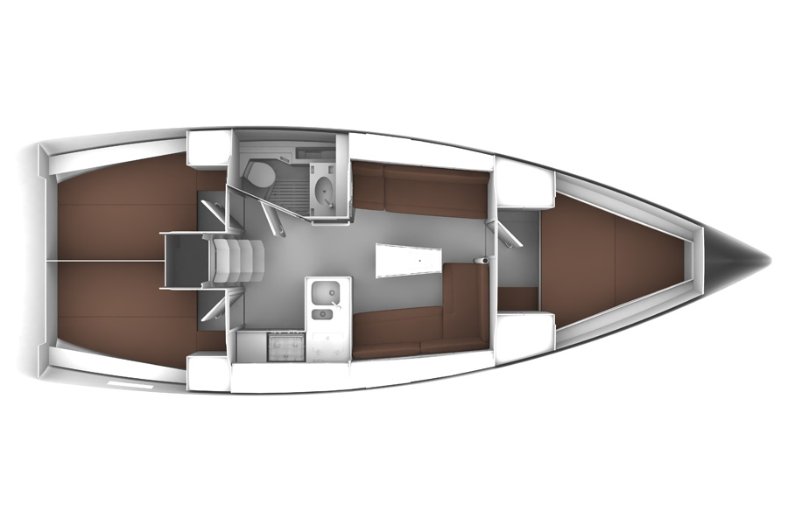

YEAR 2014/2016/2018/2020
Length overall 11,20 m | Draft 1,95 m
Beam 3,67 m | Engine Volvo 27 HP Saildrive
Water capacity 210 l + 150 l | Fuel capacity 150 l
EQUIPMENT  - Tender  - Hot water  - Cockpit table  - Roll main sail and roll genoa  - Bimini top  - Sprayhood | ELECTRICAL EQUIPMENT  - GPS with plotter  - Autopilot  - Speed and echo log  - Wind instrument  - VHF  - Radio-CD player  - Electric windlass  - Bow thruster (2016, 2018, 2020 models)  - Eberspacher heating (2016 model)
OUTSIDE  - 2 winch handles  - 2 anchors with chain  - ropes  - 6 fenders  - boat hook  - wind direction indicator  - life bouy  - 2 gas bottles  - byboat pump  - water hose + brush  - bilge pump + handle | INSIDE  - charts  - plotters + divider  - hand bearing compass  - binoculars  - pilot books  - life jackets  - first aid kit  - portable lamp  - tools  - clock + barometer  - kitchen equipment

