

MERRY FISHER 895 “ADRIANA”

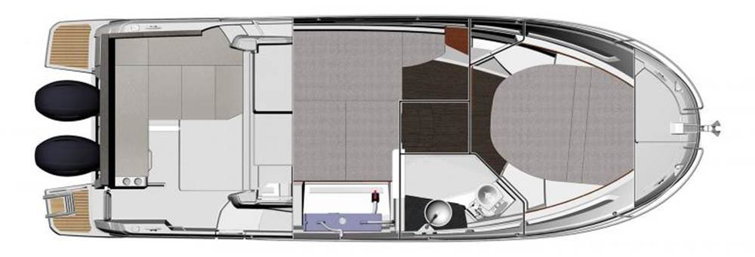

YEAR 2020
Length overall 8,90m (without platforms) | Draft 0,60m
Beam 2,99m | Engine 2x 175KS Suzuki (petrol)
Weight 3.060kg (without engines) | Air draft 2,82m- 3,08m
Water capacity 160 l | 2 cabins (4/6 berths)
Fuel capacity 2 x 200 l | 1 toilette
Cruising speed/fuel consumption | 22 knots/55 liters
EQUIPMENT  - Tender  - Cockpit table  - Bimini top  - Electric trim wings  - Cushions for cockpit bench (2 seats)  - LED lights in bow cabin & captain’s desk; on cockpit floor  - Bimini for cockpit | ELECTRICAL EQUIPMENT  - GPS with plotter  - Speed and echo log  - VHF  - Radio-CD player  - Electric windlass  - Fridge 12V/60lit.  - Bowthruster
OUTSIDE  - 2 anchors with chain  - ropes  - 6 fenders  - boat hook  - wind direction indicator  - life bouy  - 2 gas bottles  - water nose + brush  - bilge pump + handle  - shower in cockpit | INSIDE  - charts  - plotters + divider  - hand bearing compass  - binoculars  - pilot books  - life jackets  - first aid kit  - portable lamp  - tools  - clock + barometer  - kitchen equipment

