

OCEANIS 41.1
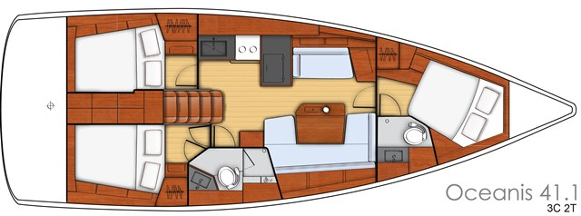

YEAR 2017/2018/2020
Length overall 12,43 m | Draft 1,75 m
Beam 4,20 m | Engine Volvo 45 HP
Displacement 8940 kg | Genoa 42 m²
Water capacity 570 l | Main sail 33 m²

Fuel capacity 200 l
EQUIPMENT  - Tender  - Teak cockpit  - Hot water  - Cockpit table  - Furling mainsail  - Roll genoa  - Electric windlass  - Bimini top  - Sprayhood | ELECTRICAL EQUIPMENT  - GPS with plotter  - Autopilot  - Speed and echo log  - VHF  - Radio-CD player with cockpit speakers  - Wind instrument  - Bow thruster  - Heating
OUTSIDE  - 2 winch handles  - 2 anchors with chain  - ropes  - 6 fenders  - boat hook  - wind direction indicator  - life bouy  - 2 gas bottles  - byboat pump  - water nose + brush  - bilge pump + handle | INSIDE  - charts  - plotters + divider  - hand bearing compass  - binoculars  - pilot books  - life jackets  - first aid kit  - portable lamp  - tools  - clock + barometer  - kitchen equipment  - TV (only 2017)

