

BENETEAU OCEANIS 46.1

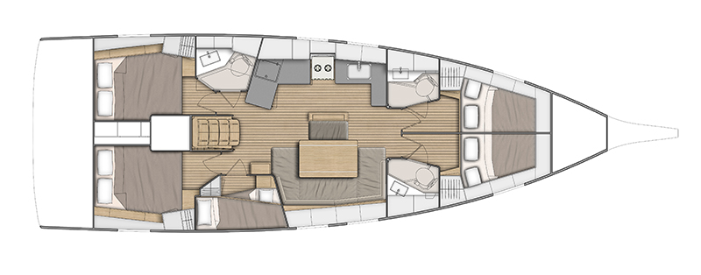

YEAR 2019
Length overall 14,60 m | Draft 2,35 m
Beam 4,50 m | Engine Yanmar 57 HP
Weight 10,6 T | Mainsail*- m²
Water capacity 570l | Genoa- m²
Fuel capacity 200l
EQUIPMENT  - Tender  - Bimini top  - Sprayhood  - Hot water  - Cockpit table  - Roll main sail and roll genoa | ELECTRICAL EQUIPMENT  - GPS chart plotter  - Autopilot  - Speed and echo log  - Wind instrument  - VHF  - Radio-CD player  - Electric windlass  - Bow thruster  - Aircondition
OUTSIDE  - 2 winch handles  - 2 anchors with chain  - ropes  - 6 fenders  - boat hook  - wind direction indicator  - life bouy  - 2 gas bottles  - byboat pump  - water nose + brush  - bilge pump + handle | INSIDE  - charts  - plotters + divider  - hand bearing compass  - binoculars  - pilot books  - life jackets  - first aid kit  - portable lamp  - tools  - clock + barometer  - kitchen equipment

