

LAGOON 450

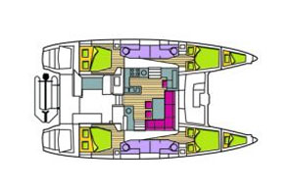

YEAR 2012/2013
Length overall 13,96 m | Draft 1,30 m
Beam 7,84 m | Engine Yanmar 2 x 54 HP
Weight 15,5 t | Mainsail 82,5 m²
Water capacity 4 x 175 l | Genoa 51,80 m²
Fuel capacity 2 x 500 l | -
EQUIPMENT  - Tender  - Bimini top  - Hot water  - Cockpit table  - Full batten main sail and roll genoa | ELECTRICAL EQUIPMENT  - GPS with plotter  - Autopilot  - Speed and echo log  - VHF  - Radio-CD player  - Electric windlass  - Wind instrument
OUTSIDE  - 2 winch handles  - 2 anchors with chain  - ropes  - 6 fenders  - boat hook  - wind direction indicator  - life bouy  - 2 gas bottles  - byboat pump  - water nose + brush  - bilge pump + handle | INSIDE  - charts  - plotters + divider  - hand bearing compass  - binoculars  - pilot books  - life jackets  - first aid kit  - portable lamp  - tools  - clock + barometer  - kitchen equipment  - 3 fridge (2 in the kitchen/saloon, 1 in the cockpit)

